MathTutor Mastery Assignment
Reflection Log
Stefan S
CSE 2140 2nd Language Programming
(MathTutor.java)
How has your program changed from planning to coding to now? Explain.
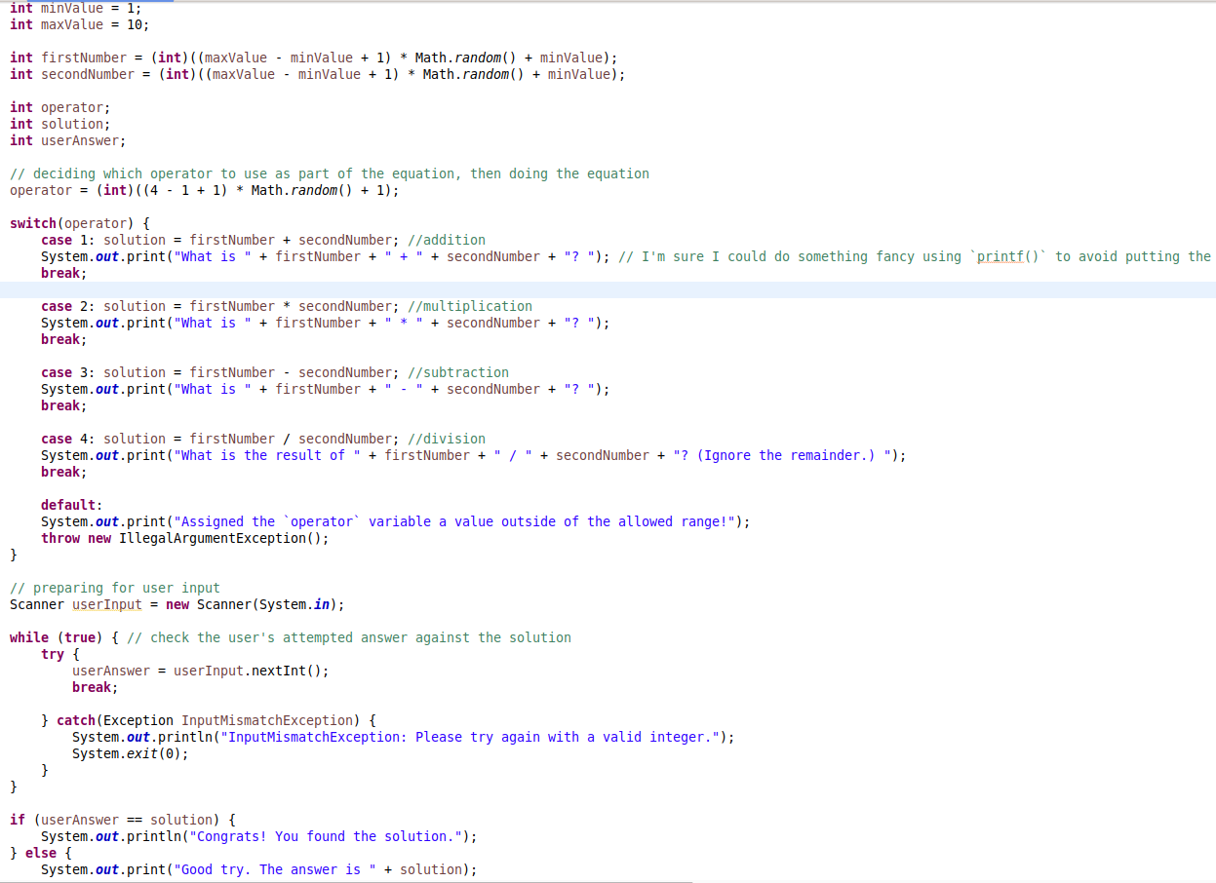
The first working version of the program also happened to be the final version of the program. The program has not changed at all from planning to coding. I could have tried to implement the printf() mentioned in the comments, but I ran out of time.
See my IPO chart and error log for information on the development of the program instead.

